Customer Purchase Frequency Analysis

1) Problem Statement:

The retail company serves a large number of customers who purchase different products over time. However, customer purchasing behavior is not the same for everyone. Some customers make only one purchase and never return, while others continue to buy repeatedly and contribute to the business regularly.
Currently, the company does not have a clear system to identify and categorize customers based on their purchasing frequency. All customers are treated similarly in marketing campaigns and promotional efforts. As a result, marketing resources such as discounts, advertisements, and promotional offers are distributed equally to all customers, regardless of their purchasing behavior.
This approach can lead to inefficient marketing spending. For example, customers who only purchase once may receive the same promotional benefits as loyal customers who contribute significantly to the company's revenue. Without proper customer segmentation, the company cannot prioritize customers who bring higher long-term value to the business.
Understanding customer purchasing patterns is essential for answering important business questions such as:
- Which customers are repeat buyers?
- Which customers purchase only once?
- How often do customers return to buy again?
- Which customers generate the highest lifetime value?
Repeat customers are especially valuable because they typically require less marketing effort to convert and often spend more over time. Loyal customers also tend to trust the brand and may recommend the company to others, contributing to long-term business growth.
To address this challenge, the company wants to perform a customer purchase frequency analysis. This analysis will examine transaction data to determine how frequently each customer purchases and categorize them into groups such as:
- One-time buyers
- Occasional buyers
- Frequent buyers
- Loyal customers
By identifying these groups, the company can develop more targeted marketing and customer relationship strategies. For example, loyal customers can receive exclusive offers and loyalty rewards, while one-time buyers can be targeted with campaigns designed to encourage repeat purchases.
The goal of this analysis is to support better customer retention planning and long-term customer value growth. By understanding purchasing behavior, the company can strengthen relationships with loyal customers, reduce customer churn, and use marketing resources more efficiently.
2) Objective:
To do the Customer Purchase Frequency Analysis based on the Customer's purchase frequency, expected products are stocked every time it stocked out, expected discounts, product quality, and the product availability of the most liked products.

3) Solutions:

- Which Customers are repeat buyers?
- Which customers purchase only once?
- How often do customers return to buy again?
- Which customers generate the highest lifetime value?
- Which products are selling fast and the company has not provided any discount on it?
- What are all the products which have been purchased by regular customers frequently?
- Shall the company provide some additional benefits to every customer irrespective of regular or occasional buyers?

4) Methodology:

- Data Collection contains the following headers has been generated by chatGpt with 1800 rows:
  - Customer’s Data - Customer ID, Customer Number, Customer Name, Place, Age, Gender, Phone Number, Customer Category
  - Customer’s Purchase Data - First Purchase Date, Second Purchase Date, Last Purchase Date, First Payment Amount, Second Payment Amount, Last Payment Amount, First Payment Mode, Second Payment Mode , Last Payment Mode, First Card Type, Second Card Type, Last Card Type, First Purchase Month, Second Purchase Month, Last Purchase Month, No. of Purchases,
  - Product and Sales Details - Product ID, Product Code , Product Name, Product Category, Product Price, Discount Available, Discount Percentage, Product Availability, Stock Out Frequency, Restock Frequency, Sales Frequency
  - Company’s Benefit to Customer - Benefit Customer, Benefit Product, Customer Benefit, Discount Percentage, Benefit Purchase Frequency, Membership Card, Membership Category

- Data Understanding includes the analysis and the corresponding data required for that.
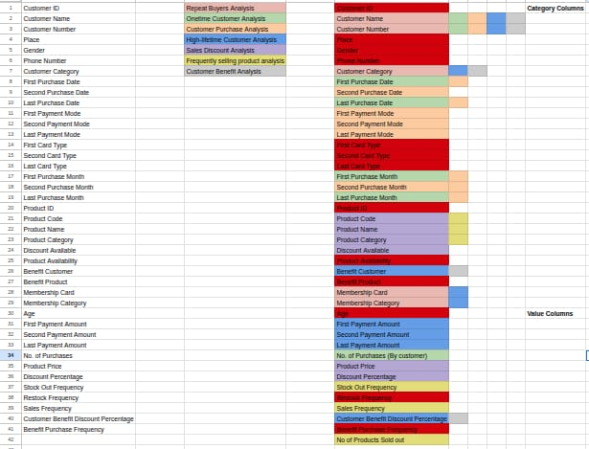
- Data Cleaning includes a remove/replace the null/empty records and replace the incorrect data like C(complete), Y(yes). However, it was not in the part of this data cleaning activity since it is generated by chatgpt, I never came across these kind of information mismatch.

- Data Transformation and Rough Dashboard:
I added the additional columns required to do the analysis like No. of Products sold out, Original Product Price, Profit, Profit Amount, Customer Benefit Amount to identify the solution which we have expected during data understanding and drew a rough Dashboard of what my dashboard should look like.
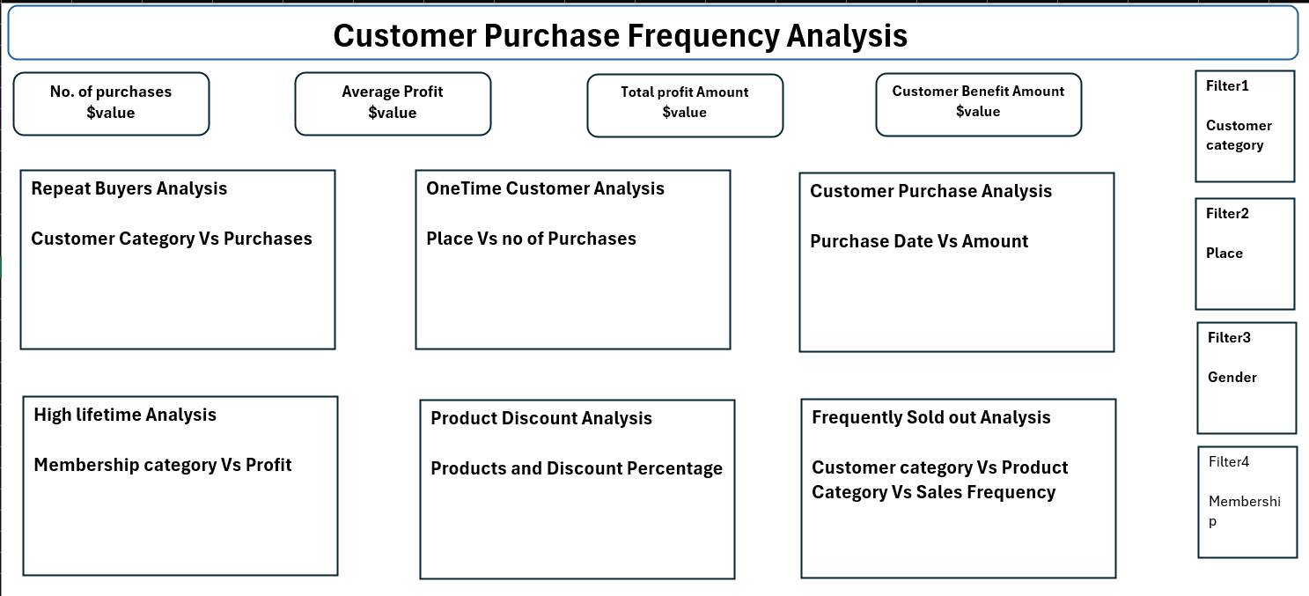

- Final Dashboard:
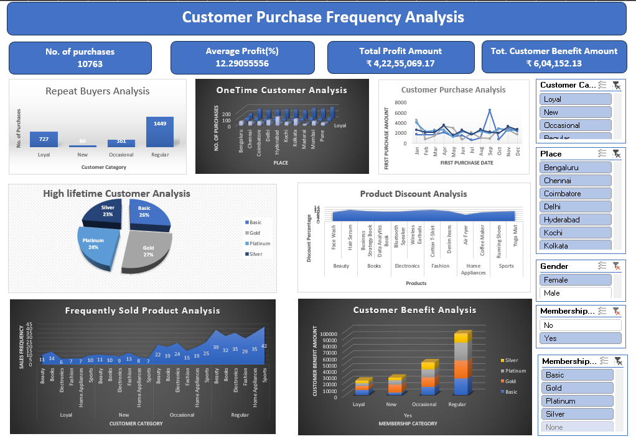

5) Tools Used:
- AI Tool : ChatGpt (Data Collection)
- Excel 2024
- Pivot Table

6) System Configuration:
Operating System: Windows
Storage: 477GB
RAM: 16GB

7) Result/Conclusion:
By analysing the Customer Purchase Frequency Analysis based on the Customer's purchase frequency indicates the type of customer and all the categories of customer’s purchase behaviour. It helps us to solve the major business problems of the retail company. So, we can modify the product and discount variations based on that.

8) Future Enhancements:
- Migration to Advanced BI Tools: Moving the analysis and visualizations from Excel to dedicated Business Intelligence software, such as Power BI or Tableau, to improve dashboard interactivity, automate data refreshes, and handle larger datasets efficiently.
- Sentiment and Feedback Analysis: Incorporating qualitative customer feedback or product review data to see how product quality directly correlates with purchase frequency metrics.

9) References:
- https://ieeexplore.ieee.org/abstract/document/11541713
- https://www.sciencedirect.com/science/article/abs/pii/S156742230900009X
- https://www.sciencedirect.com/science/article/abs/pii/S016792362300180X
- https://documentation.bloomreach.com/engagement/docs/purchase-frequency-segmentation
- https://luthresearch.com/glossary/frequency-of-purchase-analysis-uncovering-consumer-behavior-insights/

